Lab.7.1

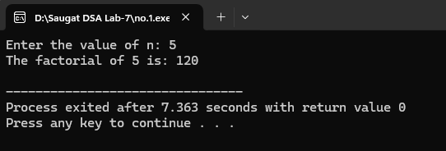

Lab.7.2

Lab.7.3

Lab.7.4

